**READ BEFORE USE.**

**Rules:**

* **This Drive belongs to** [Ethan](mailto:ethxnscheepers@gmail.com)**( @ethanscheepers on Discord)**
* **This Drive is solely sold by @ethanscheepers in Media Metas.**
* **This Drive link can be shared with Friends & Family.**
* **This Drive can NOT BE SOLD for personal gain in any sense.**

**ONLY account that can sell this Google Drive:  
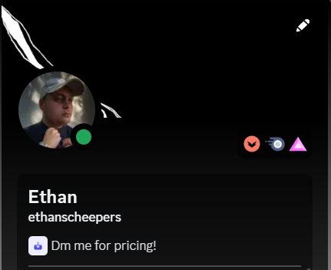**

**Enjoy - Ethan.**